**Project Design Phase-II**

**Technology Stack (Architecture & Stack)**

|  |  |
| --- | --- |
| Date | 02 Jun 2025 |
| Team ID | LTVIP2025TMID49086 |
| Project Name | iRevolution: A Data-driven Exploration of Apple's iPhone Impact in India using Tableau |
| Maximum Marks | 4 Marks |

**Technical Architecture:**

The Deliverable shall include the architectural diagram as below and the information as per the table1 & table 2

**Example: Order processing during pandemics for offline mode**

**Reference:** [**https://developer.ibm.com/patterns/ai-powered-backend-system-for-order-processing-during-pandemics/**](https://developer.ibm.com/patterns/ai-powered-backend-system-for-order-processing-during-pandemics/)

Guidelines:

Include all the processes (As an application logic / Technology Block)

Provide infrastructural demarcation (Local / Cloud)

Indicate external interfaces (third party API’s etc.)

Indicate Data Storage components / services

Indicate interface to machine learning models (if applicable)

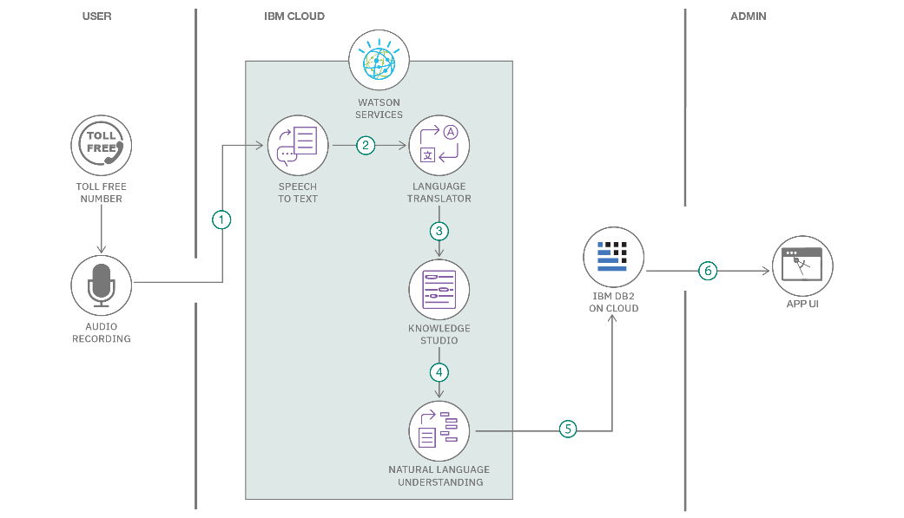

**Table-1 : Components & Technologies:**

|  |  |  |  |
| --- | --- | --- | --- |
| **S.No** | **Component** | **Description** | **Technology** |
|  | User Interface | How user interacts with application e.g.  Web UI, Mobile App, Chatbot etc. | HTML, CSS, JavaScript / Angular Js / React Js etc. |
|  | Application Logic-1 | Data transformation and cleanup logic | Java / Python |
|  | Application Logic-2 | Data visualization logic | IBM Watson STT service |
|  | Application Logic-3 | Optional insights generation or advanced logic | IBM Watson Assistant |
|  | Database | Data Type, Configurations etc. | MySQL, NoSQL, etc. |
|  | Cloud Database | Database Service on Cloud | IBM DB2, IBM Cloudant etc. |
|  | File Storage | File storage requirements | IBM Block Storage or Other Storage Service or Local Filesystem |
|  | External API-1 | Statista API / Kaggle Dataset | Statista API / Kaggle Dataset |
|  | External API-2 | NA or Optional (if second API used) | Aadhar API, etc. |
|  | Machine Learning Model | Not applicable (if no ML used) | Object Recognition Model, etc. |
|  | Infrastructure (Server / Cloud) | Hosting platform and environment | Local, Cloud Foundry, Kubernetes, etc. |

**Table-2: Application Characteristics:**

| **S.No** | **Characteristics** | **Description** | **Technology** |
| --- | --- | --- | --- |
|  | Open-Source Frameworks | Libraries used for data analysis | Technology of Opensource framework |
|  | Security Implementations | File permission, cloud security access (if data hosted online) | e.g. SHA-256, Encryptions, IAM Controls, OWASP etc. |
|  | Scalable Architecture | Scalable as Tableau dashboards can be extended to more datasets/users | Technology used Tableau Public / Tableau Cloud / Python |
|  | Availability | High availability via Tableau online/cloud | Technology used Tableau Cloud, Google Drive, Internet |
|  | Performance | Performance depends on data size, Tableau uses optimized rendering | Technology used Tableau Extracts, Tableau Engine, Data Aggregation |

**References:**

[**https://c4model.com/**](https://c4model.com/)

[**https://developer.ibm.com/patterns/online-order-processing-system-during-pandemic/**](https://developer.ibm.com/patterns/online-order-processing-system-during-pandemic/)

[**https://www.ibm.com/cloud/architecture**](https://www.ibm.com/cloud/architecture)

[**https://aws.amazon.com/architecture**](https://aws.amazon.com/architecture)

[**https://medium.com/the-internal-startup/how-to-draw-useful-technical-architecture-diagrams-2d20c9fda90d**](https://medium.com/the-internal-startup/how-to-draw-useful-technical-architecture-diagrams-2d20c9fda90d)